10.1.4 Editors - Shader Editor - Header - Add Menu
Add menu 1
Add menu - Search 1

Add menu

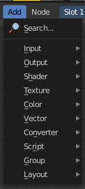
Here you will find all the nodes that you need to create your materials. A click at one of the items will create the node in the workspace at the mouse position right under the menu. It is already selected, and you can drag it around.

Note that the content of the sub menus differs, dependent in which sub mode you are. Objects have different nodes than World or Line Style.

And it differs dependent of which renderer you use. Some nodes just works with specific renderers. They will be marked as such.

Note that you need to have a material selected to activate this content.

Note also that some shaders are real resource hogs, and can slow down rendering times significantly.

Add menu - Search

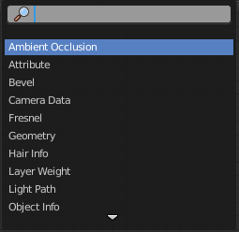
This is a search menu where you can search for specific node types in all categories.

